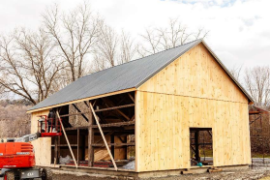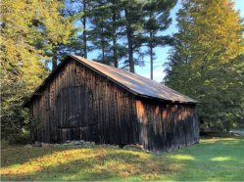A Proposal for the Williamstown Community Preservation Committee
Presented by
Williamstown Historical Museum
January 6, 2023
Dolan -Jenks Barn Preservation Project Completion
Contents
Cover Letter
Application
Budget
Resumes
FY 2021 CPC Application
The Williamstown Historical Museum is committed to the collecting and sharing of stories and artifacts of all residents of this area from across the centuries.

Board of Directors Mike Goodwin - President Susan Schneski - Secretary Paul Boyer - Treasurer Robert Burns
Donna Chenail
Linda Conway
Christine DeLucia
Carole Dolan
Barbara Halligan Fischer Charlie Hopton
Stephanie Johnson
Patricia Leach
Cynthia Payne
Stacy Sylvester
Michael Nixon –
Museum Administrator
Barn Project
ad hoc Members
Andrus Burr
Tom Sheldon
Pam Weatherbee
January 5, 2023
Williamstown Community Preservation Committee
Jane Patton, Committee Chair
Dear Ms. Patton and Members of the Committee,
Thank you for this opportunity to request $35,000 in support of the completion of the preservation of the historic Dolan-Jenks barn. Your generous help with the museum's requests in FY2021 was greatly appreciated as we began this four-year journey of moving and restoring this piece of Williamstown history. The museum values its role as a location for the collection, display, preservation, and research of local history, and support from the Community Preservation Act fund has continually made this possible.
Since 1941, Williamstown Historical Museum (WHM) has been our community's local house of history. In 2019, the museum embarked on a journey to add the historic Dolan-Jenks barn to our collection. The Jenks family built their barn in the mid-1800s along Green River Road. WHM board member Carole Dolan, a descendant of the Jenks family, and her husband, Peter, donated the barn to our museum in hopes of preserving its unique history. Babcock Brothers Restoration of Lee, MA, painstakingly dismantled the barn and has restored and rebuilt the barn on the grounds of the museum, alongside another historic building, our home - the former Little Red School House. Today, when you drive by the museum, you can see the project's near completion and admire its craftsmanship.
Unfortunately, with the pandemic, the onset of inflation, and the demand for builders, our original estimates no longer reflected today's costs for materials and labor. To stay within our original budget, it was necessary to cut aspects
of the project. In addition, other items have arisen that need to be addressed to fully showcase and make the best use of this iconic building acknowledging our community's agricultural roots.
Along with continued fund-raising, additional support from The Community Preservation Act Fund would go a long way to successfully closing this project. Thank you for the consideration of this request.
Sincerely,
Michael Goodwin, WHM Board President
The Williamstown Historical Museum is committed to the collecting and sharing of stories and artifacts of all residents of this area from across the centuries.
COMMUNITY PRESERVATION ACT FUNDING APPLICATION FY 2024
Please use additional sheets and supporting documents where
necessary.
Applications are due by January 6, 2023 at noon.
Project Name: The Dolan-Jenks Barn Preservation Project Completion Sponsor Organization: Williamstown Historical Museum (WHM)
CPA Category: Community Housing Historic Preservation Open Space Recreation (circle all that apply)
Current Project Cost: $50,000 CPA Funds Requested: $ 35,000 % 70 Total Project Cost: $352,600 CPA Funds Requested: $ 85,000 % 24
1. PROJECT DESCRIPTION – Describe the proposed project in as much detail as possible. In particular, address the following questions:
a. What are the goals of the proposed project?
The goals of the Historic Barn Preservation Project are to restore the 19th-century barn previously located at 1101 Green River Road by disassembling, conserving, and reassembling the barn on the grounds of the Williamstown Historical Museum, located at 32 New Ashford Road. The primary goals for this project are to preserve the Dolan-Jenks barn and provide access to and information about this example of an ever-dwindling population of important architectural marvels and Williamstown history.
Today, the Dolan-Jenks Barn project is coming to its conclusion. The framing, roof, and siding are erected with the goal of completion later this spring. The success of this project is due to the generosity of our members, other targeted donors, and the 2021 support of the Community Preservation Committee. At the time of that application process, we worked with a budget of $301,600 based on 2019-2020 estimates covering the dismantling, restoration, and rebuilding of the barn on the WHM property, site excavation, concrete foundation, and other related items. It should be no surprise that these 2019-2020 estimates increased as construction materials were in demand and labor costs skyrocketed.
Because we needed to adjust our expectations to stay within our established budget, some essential items needed to be cut. Other details that have become apparent since our initial budget include the need for both landscaping around the barn after construction and creating a wildflower garden to replace the footprint on our property, as requested by the Williamstown Conservation Committee, and educational display panels.
The primary goal of this aspect of our project is to fully complete the Dolan -Jenks Barn project and not have to continue to chase funding or tap into the museum's savings. The museum is a venue and historical resource hub accessible to all visitors and relies on the generosity of our member's annual support. Our hope and plans have always been to add this unique structure to our available collection while not putting our ongoing financial stability at risk.
b. Why is this project needed?
1
The Dolan-Jenks Barn Preservation Project falls within the museum's mission to preserve and promote the history of Williamstown. The barn is expected to provide increased visibility for the museum, growth in membership, and financial stability for the organization.
c. What population groups will this project serve? This historic preservation project is intended to serve all residents of Williamstown and others interested in learning about the region's past. Activities around the project will be designed to be family-friendly. The barn will be available to all who wish to visit, free of charge, and the structure on the grounds of 32 New Ashford Road will enhance the property.
d. How will this project improve the quality of life for residents?
The preservation project intends to improve the quality of life for residents of Williamstown by providing opportunities for engagement in activities and exhibits related to the town's agricultural and architectural past, thereby enhancing connection to the community. Such a treasure is a valuable and visible connection to the town's history that will be available for viewing to all for free. Please see attachment 2 for more information on potential programming related to the barn.
2. PROJECT READINESS/FEASIBILITY – Describe the project's feasibility and readiness to proceed. Address the following questions in your response:
a. Has a feasibility study been conducted? If so, please attach it to this application. If not, please offer other evidence that the project is feasible.
The WHM applied for and received Community Preservation Act funding in 2021. The original application and information regarding the project's feasibility is accessible on the CPC website at https://drive.google.com/file/d/1x_jmYhVAFrTcZuI8liulOkl0dZvuDQR7/view
b. Is the project ready to proceed? If not, what additional steps are necessary before the project can proceed?
Our current request focuses on completing our project instead of proceeding forward. As of January 1, 2023, restoration construction is nearing completion, with the framing completed and the addition of a new roof. Siding and enclosure will continue through the winter months. While we have contained cost overruns, we have discovered that with the increased costs of materials and labor since the onset of the COVID pandemic, several items needed to be cut to complete the main barn structure within budget. These items include:
• The purchase of materials and installation of a wooden floor that covers the concrete foundation
• Staining and treatment of the exterior board walls to protect them from the elements • Installation of an underground electrical conduit from the museum to the barn • Landscaping of the surrounding area, including a pathway from the museum
In addition, there are many other items needing to be addressed that were not a part of our initial planning:
• The creation of a wildflower garden was requested by the Williamstown Conservation Committee to replace the footage of the barn
• Developing weather-resistant educational panels and materials recognizing the Dolan Jenks Barn's and Williamstown's agricultural history
Because of these cost increases and additions to our project, we expect to use our budgeted cost over-run totals fully. We hope to come in at budget but will need to address these final aspects of the project.
3. PROJECT TASKS/IMPLEMENTATION SCHEDULE – Provide a detailed list of required tasks, such as studies, engineering work, architectural design, permitting, financing, and construction. In addition, provide a detailed implementation schedule, including dates for project initiation, key milestones, and project completion.
2
Despite some setbacks due to the current construction and labor climate, we have stayed somewhat close to our original timetable.
Winter 2021 – Spring 2021:
- additional studies, surveys, design plans, and other documents were carried out to prepare for permitting for project (please see attachment 5)
Spring 2021:
- disassembly of Dolan-Jenks barn and transport to David Babcock's shop for repair and restoration
- targeted fundraising focusing on potential major donors
Summer/Fall 2022 – Winter 2023
- assembly of the barn on WHM grounds
Spring 2023
- Staining of the external area of the barn
- Landscaping and wildflower garden completion
Winter 2023/2024
- Installation of wood floor (delay based on availability of contractors)
4. PROJECT TEAM - List the proposed members of the project team and the role of each person or organization. Describe how those team members' experiences will contribute to the success of the project. Attach resumes for key team members.
While the leading players have continued, the former WHM Executive Director, Sarah Currie, resigned in the fall of 2021. Our new Museum Administrator, Michael Nixon, and current Board President, Mike Goodwin, have been added to the team. Their resumes are attached.
David Babcock, Contractor, and owner of Babcock Brothers Restoration is an experienced timber framer with an impressive portfolio of work. His clear knowledge of historic barns and his firm's work to stabilize the Dolan-Jenks barn is evidence that his talent and dedication will lead to a successful project.
Andrus Burr, former WHM Board member and Project Manager is a renowned local architect with decades of experience. His expertise in historic barns and in carrying out hundreds of successful projects will be an asset to the Dolan-Jenks Barn Preservation Project.
Linda Conway, a long-time board member and the former board president has a proven track record in leading successful fundraising efforts. As a recipient of the Scarborough Solomon Flynt Community Service Award, her commitment to local service is clear. Her dedication and willingness to see the Dolan-Jenks Barn Preservation Project through will lead to its success.
Michael Nixon serves as WHM Museum Administrator and is dedicated to promoting all areas of Williamstown's history. A historian and former educator Michael's experience provides a foundation that will help make the Dolan-Jenks Barn Preservation Project a success.
Mike Goodwin serves as the current board president. He has experience in board leadership, having served on numerous local organizations, including the Williamstown Community Chest and Louison House Properties in North Adams.
3
5. SOURCES AND USES OF FUNDS -- Provide a detailed list of the sources and uses of funds for the project:
a. Describe your strategy for funding your project. Describe all anticipated funding sources, including state, federal or private grants; capital campaigns; loans, CPA, or other. The WHM successfully raised the $301,600 goal set for this project. Solicitation of board members targeted donors, and museum members garnered 83% of our target, with the 2021 CPC funding rounding out the total.
As the project proceeded through the latter half of 2022, we saw an increase in excavation costs and the concrete foundation costs of 58%. The barn's dismantling and restoration are currently running than 10-15% higher than estimated. We have planned for overages but expect to be at or slightly over budget by the end.
In December of 2022, we sent out a year-end mailing to our members asking for support in helping us "Close the Barn" and meet our $50,000 deficit to complete the project and not have to fall back on the museum operating budget. We have a goal to raise $15,000 from this year-end appeal. This will be our only additional appeal for the project, as the museum operates and relies on our annual membership fees for support.
b. Uses of funds. Describe all anticipated expenditures: costs of studies, consultants, permits, engineering, architectural design work, construction, landscaping, and all other identified uses. Whenever possible, include exact cost estimates provided by experts.
Because of ongoing construction, we have not been able to secure actual estimates. The estimates reported are based on current market values for hardwood flooring and Cabot brand weathering stain. They are based on the barn's square footage and current market and labor costs forecasted by committee member and architect Andrus Burr.
c. Total Sources and Total Uses MUST BE EQUAL TO ONE ANOTHER. SOURCES USES
December 2022 member and donor solicitation
2023 Funding
requested from CPA Grant
$ 15,000
$
35,000
Installation of
wood flooring $ $25,000
Exterior stain
and application $ $6000 Electrical
Conduit from
museum to
barn
Landscaping
and wildflower
garden
Educational Panels &
Materials
_{Additional}
$ $7000
$ $6000 $ $2000
_{cost overruns} $ $4000
Total Sources | $ | 50,000 | = | Total Uses | $ | $50,000

4
6. ADDITIONAL INFORMATION – Provide any additional information that you believe is relevant to this application.
7. CONTACT INFORMATION
Contact Person: Mike Goodwin
Address 46 Sunset Drive City: Williamstown State MA Zip 01267
Phone 413.441.6502 E-mail mikegood44@gmail.com
Please submit completed application in electronic format to:
Community Preservation Committee
c/o Town Manager's Office
rmenicocci@williamstownma.gov
CPC Application Review Process:
1. A voluntary pre-application meeting with a sub-committee will be available to any prospective applicant. This is intended to answer questions and to assist applicants in developing effective applications. These meetings will be scheduled on December 12 from 9 to 11 am and December 14 and 15 from 1 to 3 pm. Please contact the Town Manager's office for an appointment. These meetings will be held in person or remotely on Zoom.
2. The CPC members carefully review each application.
Applicants meet with the CPC in public session to answer any questions and provide clarification about the application they have submitted. Based on this meeting, applicants often determine that their applications would benefit from revision and/or supplementary information. In such cases, the CPC members will review revised applications. We ask that applicants highlight revisions directly in the proposal, and with a covering letter summarizing changes.
3. Applicants may meet with the CPC a second time if necessary.
4. Further questioning by CPC members will focus on:
• Qualification. All funded applications must comply with statewide
CPA regulations.
• Merit. Since the Williamstown CPC recommends funding projects with town tax dollars, it looks carefully at the merits of each proposed project,
including community impact and return on investment.
• Affordability. Each fiscal year, Williamstown's participation in the Community Preservation Act provides a limited pool of funds for historic preservation, affordable housing, and open space and recreation projects. In some cases, the CPC may determine that although a project both qualifies and has merit, it cannot be funded because of fiscal limitations.
5
5. Projects receiving support from a majority CPC members will be recommended for funding to the town. The CPC's funding recommendations are reviewed but may not be changed by the Select Board and the Finance Committee, and then presented for vote at the Annual Town Meeting in May. To receive funding, CPC-recommended projects must be supported by a majority of voters at Annual Town Meeting.
Of Note:
1. The CPC requires that all funded projects have a "sunset clause," limiting the time period that the funds will be available for a given project, unless that sunset clause is extended for a reasonable period of time by the Town Manager due to unanticipated delays or conditions. If the project is not completed prior to the date specified in the Town Meeting Warrant Article, or as extended by the Town Manager, funds will revert back to the town for alternative allocation as recommended by the CPC.
2. The CPC is not obligated to allocate 100% of available funds. It may decide against funding qualified, meritorious projects, reserving funds for future allocation.
3. The CPC will only recommend funding successful applications in the entirety of the request. Amendments to funding amounts may not be accepted or recommended after the submission of the application.
4. Awarded CPC funds will be disbursed by the Town Manager's office, subject to presentation of appropriate documents (invoices, receipts, etc.).
5. Awarded CPC funds may not be available until after tax revenues are collected to support the project, as determined by the Town Manager's office.
6
WHM Dolan – Jenks Barn Project Budget
Babcock Restoration 2020 budgeted 2022 projected Increase Completion of barn
dismantling $35,000.00 $35,000.00
Move salvage material
Storage, and repair barn
frame $65,000.00 $70,000.00 $5,000.00
Erect barn frame on new
foundation $30,000.00 $45,000.00 $15,000.00 Barn siding and roofing $50,000.00 $60,000.00 $10,000.00 Build Loft $0.00 $10,000.00 $10,000.00 Completion of work $30,000.00 $20,000.00 -$10,000.00 Total $210,000.00 $240,000.00 $30,000.00
Actual
Other Expenses 2020 Budgeted
Galusha excavating and
Grady & Jennings concrete
payments Increase
foundation $27,000.00 $46,650.00 $19,650.00 Studies, Surveys and
Design Plans $8,500.00 $8,275.00 Mailings, marketing 0.00 $1,211.00 $1,211.00
Add'tl planned costs $16,100.00 $16,100.00
Electrical conduit from
museum to Barn $5,000.00 $7,000.00 Projected costs for any
35.6 % increase anticipated costs
septic system rehabilitation $2,500.00 $3,400.00 Accessible path from
museum to barn $3,000.00 $4,100.00
Unexpected expenses $4,000.00 $0.00
Additional Insurance $1,600.00 $1,600.00
Cost Overruns $40,000.00 $0.00 Project Total $301,600.00 $312,236.00 $10,636.00 Install of wood flooring $25,000.00
Exterior stain $6,000.00
Educational panels $2,000.00
Landscaping/garden $5,000.00
Total Project Costs $350,236
7
8
Michael Nixon
61 Jamieson Heights, Williamstown, MA
michaelnixon60@gmail.com
413-749-2927
Education
University of Melbourne, 2000
BA Education, honors
William Angliss Institute, Melbourne, Australia
Bachelor of Culinary Management 1982
Scotch College, Melbourne, Australia
Secondary School
Skills & Attributes
➢ Substantial management experience with oversight of budgets ➢ Interest and experience in creative ways to engage people in history ➢ Solid understanding of financial reports
➢ Awareness of marketing needs through social media
➢ First-rate communication skills
➢ Experience working with volunteers, notably seniors
➢ Experience in cutting costs effectively and delivering quality services within budget for the YMCA
Historical Programming and Education Experience
* Initiated educational programs looking at the changing landscape of the Berkshires, specifically Hopkins Forest. Organized field trips for school age children.
* Planned and implemented a comprehensive educational program for school age students using drama as a vehicle for learning and engagement. Using the New Ashford historic one-room schoolhouse, students went back in time and spent a week at school in 1905. (Sarah Currie assisted)
* Created a documentary movie, Back in Time, of the New Ashford schoolhouse experience, shown at Images Cinema.
* Visited other local museums and evaluated their educational programs
* Implemented innovative history based curriculum in Australian elementary school for sixth graders
Professional Experience
History drama educator, Williamstown 2019
Elementary School Teacher, Melbourne and Williamstown, 2001 -2009 Substitute teacher, 2017 - 2019
Food Service Director, Cambridge Senior Center, Cambridge, MA 1995 – 97 Manager, food services, Orchards Hotel, Williamstown, 1994 Director, food services, Becket Chimney Corners YMCA Camps 1987 – 1993
Professional Development
Harvard Extension School, Boston 1996
Creative Writing
Community Involvement
Caretaker CSA Farm member
Images Cinema
Williams College Children’s Center, Advisory Committee
Earlier Interests and Employment
Outdoor Education Guide, Becket Chimney Corners YMCA Camps Program coordinator, Elderhostel, Becket Outdoor Center
Michael S. Goodwin
Williamstown, MA 01267 (413) 441-6502 / mikegood44@gmail.com
CAREER SUMMARY
Experienced higher education professional with a varied career encompassing residence life, mental health counseling, teaching, student involvement and leadership, and financial aid. Seeking to apply these collective experiences and skills at a college or organization focused on student access and opportunities.
EXPERIENCE
EDUCATION
Ed.D. Higher Education Administration, ABD
New England College,
Henniker, NH
MA Counseling Psychology, Framingham State University, Framingham, MA 1993
B.A. History,
University of Southern Maine, Portland, ME 1989
PROFESSIONAL SKILLS
• Active listener
• Adaptability
• Communication
• Conflict resolution
• Creativity
• Critical thinking
• Empathy
• Excel
• Leadership
• Presenting
• Public Speaking
• Problem-solving
• Non-profit management • Relationship building • Team building
• WordPress web-design
Assistant Director of Student Financial Services
Williams College, Williamstown MA Aug. 2017-present • Determine financial aid eligibility of prospective and current students • Cultivate relationships and advising students and families in all aspect of financing college education
• Counsel and support families on payment methods and strategies • Liaison with athletic department to support admissions recruitment • Primary contact for prospective families using the college’s Net Price Calculator and discussing aid eligibility
• Collaborate on formulation of policies and procedures • Manage federal work-study and off-campus partner employment • Design and upkeep of department website
• Present financial aid seminars for local high school families • Co-chair state-wide monthly on-line FAFSA Day support events
Assistant Dean of Students/Director of Student Involvement & Leadership / Title IX Coordinator
Southern Vermont College, Bennington, VT July 2012 – July 2016 • Managed extra-curricular opportunities on small, liberal arts campus • Led Events Board in planning weekly programming events • Supervised Civic Engagement Coordinator and three student assistants • Responsible for management of multiple budgets totaling $400,000 • Organized fall Family Weekend and spring carnival weekend • Reestablished and advised Student Government Association • Responsible for the implementation new student orientation programs • Oversaw student clubs and aided in the develop of new organizations • Member of Case Management and Threat Assessment Response teams • Chaired Diversity, Retention, Campus Wellness and Safety committees • Reported compliance of all Title IX and VAWA federal regulations. • Provided Responsible Employee training for all faculty and staff • Led student life operations in the Dean’s extended absence • Shared in administrator and dean on-call duty rotation
Director of Counseling Services and Adjunct Faculty
Southern Vermont College, Bennington, VT Aug. 2007 – July 2012 • Provided psychotherapeutic services, addressing varying mental health and relational issues • Maintained confidential record in line with all state and federal rules and guidelines • Supervised part time licensed clinicians
• Coordinated alcohol and other drug prevention programming, assessments, and statistical analysis of student behavior and risks
• Established and advised student organizations: Peer Health Educators, Colleges Against Cancer, and PRIDE Gay Straight Alliance
• Served as adjunct faculty in Social Sciences Department. Courses included: PY 103 Intro to Interviewing and Counseling PY 205 Chemical Dependency PY 208 Counseling the Individual and Family PY 303 Human Sexuality PY 403 Advanced Counseling Techniques PY 405 Group Counseling
Director of Development
Northern Berkshire Healthcare, North Adams, MA May 2004 – Dec. 2006 • Directed annual giving and capital campaign fund raising efforts and special events designed to provide operating support to North Adams Regional Hospital and its multi-faceted healthcare system
• Supervised two professional staff and numerous community volunteers
Coordinator of Annual Giving
Massachusetts College of Liberal Arts, North Adams, MA Jan. 2003 – May 2004 • Responsible for development and implementation of strategies for prospective donors
Mental Health Counselor/Coordinator of the ADEPT Program
Massachusetts College of Liberal Arts, North Adams, MA Aug. 1996 – December 2002 • Licensed clinician providing wide range of student focused therapeutic services • Served as Wellness Educator for Alcohol and Drug Education, Prevention program • Advised national and regional award-winning student peer health education organization
Case Manager/Counselor
Advocates, Inc., Framingham, MA Sep. 1990 – Aug. 1996
Residence Hall Director
Framingham State College, Framingham, MA June 1990 – June 1993
BOARD OF DIRECTORS AND COMMUNITY INVOLVEMENT
Williamstown Historical Society September 2021 - present MAFSAA FAFSA Day Committee May 2020 - present (Co-Chair) Non-Profit Center of the Berkshires Award for Outstanding Board Leadership May 2019 Louison House, Inc. Homeless Shelter; North Adams, MA 2015 - present (Chair) Williamstown Darts League; Williamstown, MA 2004 - present (Chair) Williamstown Community Chest; Williamstown, MA 2009 - 2016 (Chair 2012-2014)
Southshire Partnership for Healthy Community; Bennington, VT 2008-2014 (Chair 2012-2014) BFaIR (Berkshire Family and Individual Resources); North Adams, MA 2006-2010
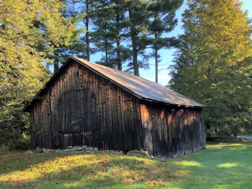A Proposal for the Williamstown Community Preservation Committee
Presented by
Williamstown Historical Museum
January 8, 2021
Contents
Dolan-Jenks Barn Preservation Project
• Cover letter
• Application Form
Attachments:
1. Dolan-Jenks Barn description
2. Potential programming related to the preserved barn on the grounds of the WHM 3. Comments about the importance of Dolan-Jenks Barn Preservation Project 4. Estimate for services by Guntlow & Associates, Inc.
5. Guntlow & Associates Barn location design concepts
6. Estimate for preservation of barn by David Babcock of Babcock Brothers Restoration 7. Estimate for foundation from Grady & Jennings Concrete, Inc.
8. Project team member resumes
9. List and bios of Williamstown Historical Museum board members
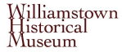
Board of Directors
Linda Conway
President
David Westall
Vice President
Paul Dube
Treasurer
Susan Schneski
Recording Secretary
Joe Bergeron
Dante Birch
Paul Boyer
Robert Burns
Andrus Burr
Donna Chenail
Carole Dolan
Patricia Greenberg Stephanie Johnson Patricia Leach
Cynthia Payne
Patrick Quinn
Mary Strout
Sarah Currie
Executive Director
January 8, 2021
Williamstown Community Preservation Committee
Phil McKnight, Committee Chair
Dear Mr. McKnight and Members of the Committee,
Thank you for this opportunity to request $50,000 in support of a project to preserve the historic Dolan-Jenks barn. Thank you, also, for your generous support of the museum’s requests in previous years, most recently in FY2020, to support the conservation of the town’s 18th century ledger of animal markings. The museum is grateful for its position as a location for the collection, display, preservation, and research of local history, and support from the Community Preservation Act fund has helped make that possible.
The Williamstown Historical Museum is the town’s history center and was founded in 1941, as the House of Local History, to preserve and to promote knowledge of the town's history. In 1994 the museum was designated the “official custodian of town artifacts,” and we take our role seriously. The WHM works to document the diverse people and buildings, the associations and businesses, the institutions and events, that form the town's history from the earliest days to the present time. The museum’s vast collection includes photographs, documents, and artifacts from the 1700s to the present day, as well as published works related to the town’s history. The museum is committed to providing free access to the collection for all and maintains an online collection for those who wish to access the collection from afar.
A successful move to the South Center School in 2016 provided a new location for the museum to mount exhibits, host events and programs, and facilitate research. Despite the pandemic, the museum continues its work to provide meaningful content to those interested in the town’s history. The year ahead will be filled with online engagement consisting of lectures, emails and online exhibits related to local history, and even on-site exhibits despite limited open hours meant to keep our visitors safe.
The museum has embarked on a special project to preserve the iconic Dolan-Jenks barn, currently located at 1101 Green River Road. The barn will be disassembled, restored, and reassembled on the grounds of the WHM, which will bring new life to a barn that is over 170 years old. The prospect of opportunities to connect with the past while engaging with the present is inspiring. On the grounds of the WHM the barn will be available for visitors to learn more about the town’s agricultural past and the methods of construction used in previous centuries.
The Community Preservation Act Fund grant will help make the preservation of this barn possible. Thank you for your kind consideration of our request.
Sincerely,
Sarah Currie
COMMUNITY PRESERVATION ACT
FUNDING APPLICATION FY 2022
Please use additional sheets and supporting documents where necessary. Applications are due by January 8, 2021 at noon.
Project Name: The Dolan-Jenks Barn Preservation Project
Sponsor Organization: Williamstown Historical Museum
CPA Category: Community Housing Historic Preservation Open Space Recreation (circle all that apply)
Total Project Cost: $ 301,600 CPA Funds Requested: $ 50,000 % 17
1. PROJECT DESCRIPTION – Describe the proposed project in as much detail as possible. In particular, address the following questions:
a. What are the goals of the proposed project?
The goals of the Historic Barn Preservation Project are to restore the 19th century barn located at 1101 Green River Road by disassembling, conserving, and reassembling the barn on the grounds of the Williamstown Historical Museum, located at 32 New Ashford Road. The barn and its restoration will provide opportunities to educate visitors about the importance of such structures and their significance to the agricultural life of Williamstown's past. The primary goals for this project are to preserve the Dolan-Jenks barn and provide access to and information about this example of an ever-dwindling population of important architectural marvels.
b. Why is this project needed?
In 2018 Carole and Peter Dolan, the owners of the barn located at 1101 Green River Road, offered to donate the barn to the Williamstown Historical Museum. After extensive deliberation, numerous conversations with the donors, and meetings with timber framing experts, it became clear that the preservation of the barn was imperative. The Dolan-Jenks barn is significant because it is a surviving member of an ever-dwindling group of early- and mid-19th century barns. Without preservation, it will deteriorate and will be lost. This striking building is memorable and was used to support agriculture, transportation, and daily life in the first century after Williamstown’s settlement. Its layout is unique, and the barn has a story that should be told. By adding it to the WHM collection, the building will become a public asset, making it possible to educate the community about an array of topics ranging from traditional construction skills used in this and similar buildings to the natural history of the region, connecting the barn’s 45’ wooden beams with the trees and landscape of the 1800s. The Dolan-Jenks Barn Preservation Project falls within the museum’s mission to preserve and promote the history of Williamstown. The barn is expected to provide increased visibility for the museum, growth in membership, and financial stability for the organization.
c. What population groups will this project serve? Please estimate how many residents will benefit.
This historic preservation project is intended to serve all residents of Williamstown and others interested in learning about the region’s past. Activities around the project will be designed to be family friendly. The barn will be available to all who wish to visit, free of charge, and the structure on the grounds of 32 New Ashford Road will enhance the property.
d. How will this project improve the quality of life for residents?
This preservation project is intended to improve the quality of life for residents of Williamstown by providing opportunities for engagement in activities and exhibits related to the town’s agricultural and architectural past, thereby enhancing connection to the town and community. Opportunities for interpretation about the life of the barn and its owners abound and will be of value to current-day residents who are interested in gaining a deeper understanding of the town and its agricultural history. This iconic barn will deteriorate and will be lost if it is not preserved. Such a treasure is a valuable and visible connection to the town’s past that will be available for viewing to all for free. Please see attachment 2 for more information on potential programming related to the barn.
2. PROJECT READINESS/FEASIBILITY – Describe the project’s feasibility and readiness to proceed. Address the following questions in your response:
a. Has a feasibility study been conducted? If so, please attach it to this application. If not, please offer other evidence that the project is feasible.
Preliminary studies identifying potential placement of the barn on the grounds at 32 New Ashford Road have been carried out by Guntlow & Associates. Please see attachment 5 for the three design concepts proposed by Guntlow & Associates. Further studies will be carried out, as detailed in attachment 4. Upon completion of these studies, the museum will work with Guntlow & Associates, the town’s Community Development Department, and contractor David Babcock to pursue permitting for the project.
With over 63% of the project already funded with cash in hand and additional promised pledges, the museum is confident that the remaining 37% can be raised within the proposed time frame. A grant from the CPA fund would complement and encourage the additional fundraising the museum plans to carry out.
b. Is the project ready to proceed? If not, what additional steps are necessary before the project can proceed?
The project will be ready to proceed in the spring of 2021.
3. PROJECT TASKS/IMPLEMENTATION SCHEDULE – Provide a detailed list of required tasks, such as studies, engineering work, architectural design, permitting, financing, and construction. In addition, provide a detailed implementation schedule, including dates for project initiation, key milestones, and project completion.
Please find the timeline on the following page.
Dolan-Jenks Barn Project Timeline
Winter 2021 – Spring 2021:
- additional studies, surveys, design plans, and other documents carried out to prepare for permitting for project (please see attachment 5)
Spring 2021:
- disassembly of Dolan-Jenks barn and transport to David Babcock’s shop for repair and restoration
- targeted fundraising focusing on potential major donors
Fall 2021 – Summer 2022:
- assembly of barn on WHM grounds (includes barn raising event and other programs) Photographs and progress reports about the project will be shared throughout the process.
4. PROJECT TEAM - List the proposed members of the project team and the role of each person or organization. Describe how those team members’ experiences will contribute to the success of the project. Attach resumes for key team members.
Please see attachment 8 for team member resumes.
David Babcock, Contractor and owner of Babcock Brothers Restoration, is an experienced timber framer with an impressive portfolio of work. His clear knowledge of historic barns and the work his firm has already done to stabilize the Dolan-Jenks barn is evidence that his talent and dedication will lead to a successful project.
Andrus Burr, WHM Board member and Project Manager, is a renowned local architect with decades of experience. His expertise in historic barns and in carrying out hundreds of successful projects will be an asset to the Dolan-Jenks Barn Preservation Project.
Linda Conway serves as WHM Board President and has a proven track record in leading successful fundraising efforts. As a recipient of the Scarborough Solomon Flynt Community Service award her commitment to local service is clear. Her dedication and willingness to see the Dolan-Jenks Barn Preservation Project through will lead to its success.
Sarah Currie serves as WHM Executive Director and is dedicated to promoting all areas of Williamstown’s history. She has carried out numerous CPA funded projects and other grant funded special projects, special exhibits, and the renovation of and move of the museum to the South Center School. Her experience provides a foundation that will help make the Dolan-Jenks Barn Preservation Project a success.
5. SOURCES AND USES OF FUNDS -- Provide a detailed list of the sources and uses of funds for the project:
a. Describe your strategy for funding your project. Describe all anticipated funding sources, including state, federal or private grants; capital campaigns; loans, CPA, or other. The Williamstown CPC strongly encourages applicants to seek and secure funding for their projects from other sources. We will prioritize projects for which the CPC would participate with other funding sources.
The Williamstown Historical Museum already has 57% of the funding for the Dolan-Jenks Barn Project in hand. Another 6% has been pledged and will arrive in 2021 and 2022. The museum is requesting a grant from the CPA fund that will comprise 17% of the cost of the project. The museum is prepared to seek targeted funds from individual donors for the remaining 20% of the project’s costs. Based on the feedback from a focus group held to identify the feasibility of this project, the museum is confident that these additional funds can be raised within the projected timeline.
b. Uses of funds. Describe all anticipated expenditures: costs of studies, consultants, permits, engineering, architectural design work, construction, landscaping, and all other identified uses. Whenever possible, include exact cost estimates provided by experts.
c. Total Sources and Total Uses MUST BE EQUAL TO ONE ANOTHER. SOURCES USES
Cash in hand from  individual donors | $ | 171,000 |  | Disassembly, repair, and reassembly of barn on site, based on  estimate from David Babcock | $ | 210,000
Pledges from individual donors | $ | 20,000 |  | Cost overruns for above | $ | 40,000
Funding requested from CPA grant | $ | 50,000 |  | Excavation, full  perimeter foundation 30’x50’x5” slab | $ | 27,000
Fund raising from  targeted donors and broader, theme-specific campaign | $ | 60,600 |  | Studies, surveys, and design plans to prepare for permitting for the project | $ | 8,500
 |  |  |  | Electrical conduit from museum to barn | $ | 5,000

SOURCES |  |  |  | USES
 |  |  |  | Projected costs for any septic system  rehabilitation | $ | 2,500
 |  |  |  | Additional insurance | $ | 1,600
 |  |  |  | Placeholder for  accessible path from museum to barn | $ | 3,000
 |  |  |  | Unexpected expenses | $ | 4,000
Total Sources | $ | 301,600 | = | Total Uses | $ | 301,600

6. ADDITIONAL INFORMATION – Provide any additional information that you believe is relevant to this application.
Please see attachments 1 – 9.
7. CONTACT INFORMATION
Contact Person: Sarah Currie, Executive Director of the Williamstown Historical Museum Address: 32 New Ashford Road City: Williamstown State: MA Zip: 01267 Phone: 413-458-2160 Email: sarah@williamstownhistoricalmuseum.org
Attachment 1.
Dolan-Jenks Barn Description
The barn at 1101 Green River Road in Williamstown sits on the property currently owned by Carole and Peter Dolan. Carole is a descendant of the Jenks family who, for several generations, owned the barn, the brick house at 1129 Green River Road, and surrounding property that once included a working farm with 12 barns or ancillary buildings, in addition to the barn that remains. While most of the structures of the original farm are no longer standing, the barn likely dates from between 1840 to 1860, consistent with historical records dating the brick house to 1820. The barn is an English style dropped-tie beam, 3-bay, 4-bent barn with a common purlin system and common rafters. An English style barn is common for this time period and geographic location, though there are design characteristics of this barn that are less common and indicate a possible use other than agriculture. More recently used primarily for storing farm equipment and vehicles, the barn was referred to as “the ice-house” by later generations of the Jenks family. The barn structure has changed very little over the years and has remained in the Jenks/Green/Dolan family since it was built in the 1800s.
This barn hints at a purpose other than agriculture, perhaps storage. First, the barn was designed to be two stories. Second, the barn was designed for gable entry on both levels with a half-bank lending access via a ramp to the second level on the west end. Third, the atypical lack of transverse bracing beneath the tie beams indicate that this barn may have been used for storage of wagons or other vehicles or for another purpose where circulating at the ground level was required. The large open space on the lower level would have allowed enough room for a wagon to circulate by making a u-turn within the barn without interruption by diagonal bracing or interior posts, which would have obstructed free passage. The frame is likely all original to this building (except for the added posts at the interior ground level and tying rods) and not repurposed from other buildings, except for the use of a few recycled parts in the gable bents. The barn currently stands on a stone foundation.
By adding the barn to the grounds of the Williamstown Historical Museum, the building will become a public asset, making it possible to educate the community about an array of topics ranging from traditional construction skills used in this and similar buildings to the natural history of the region, connecting the barn’s 45’ wooden beams with trees and landscape of the 1800s.
Attachment 2.
Potential programming related to the preserved barn on the grounds of the WHM
- Throughout the project, information about the Dolan-Jenks barn, this preservation project, its purpose, and value will be provided to the community, along with progress reports about the disassembly and other portions of the project.
- A barn raising could serve as a learning opportunity and an occasion for a community gathering if COVID restrictions have been lifted.
- Photographs, diagrams, and comprehensive labels about the history, construction, and restoration of the barn will provide visitors with important information about the history of the barn, its contents, and the people who originally used the barn. Exhibits will allow visitors to learn more about how the barn may have been used in its early years and how that use may have evolved as farming techniques, trends, and needs changed over time.
- The barn itself and hand-hewn beams represent a set of treasured and traditional skills that have been virtually lost. These skills can be revisited in potential programs and demonstrations that would be related to joinery, tool use, ice harvesting and storage, farm equipment use and care, etc.
- Old farm tool and equipment donations will be displayed in rotating and permanent museum exhibits.
- On the grounds of the WHM the barn will continue to serve as a memorable historic structure in South Williamstown structure, reinforcing the organization’s and the town’s commitment to history and historic preservation.
- Natural history programs related to the environment and landscape in the 1800s will be presented. Programs will focus on the effect of farming and building construction on the environment and how the building reflects the natural landscape of the 19th century.
- Timber framing and other demonstrations will provide ideal opportunities to connect with the traditional methods used to construct the barn.
Attachment 3.
Comments about the importance of this project from a skilled local timber framer, Anthony Samale of Berkshire Mountain Design Build:
My belief is that there is great value in this endeavor. In addition to preserving our disappearing architectural heritage (especially barns), the process and media generated therefrom would provide a living exhibit of not only the finished and restored building, but also a well-documented insight into the process by which these buildings were crafted and erected. I believe that this would serve as a tool for educating our community and future generations about our building heritage and cultural landscape. It is thought that this undertaking by the museum, in the public eye, would inspire more support for the future preservation of these buildings. I have over the last twenty years seen numbers of these buildings go from structurally sound to piles of rubble in the same timeframe. They are disappearing by the thousands. With social media, film, photos and exhibits both during the process and after, this project could open the eyes and hearts of thousands while providing a great asset to the museum and community of Williamstown. Additionally, the barn could be used for venues, education, and other exhibits in the future.
Attachment 4.
Estimate for services by Guntlow & Associates, Inc.
1. Delineation of bank of the Green River (and bordering vegetated wetlands if present) and topographical survey of the 32 New Ashford Road property, specifically the open lawn areas north and east of the existing schoolhouse building. Preparation of a base plan for design and permitting purposes showing site features and approximate property line based on available plan information. ($1800)
2. Design concepts of barn location and associated riverfront improvement plantings for review by you. ($1000)
3. Finalize plans for permitting and site construction (foundation design not included) ($1200)
4. Preparation and submission of Notice of Intent for the barn reconstruction process and attendance of a site visit and hearing. ($1500)
5. Submit to Natural Heritage Endangered Species Program (NHESP) for proposed work within mapped sensitive areas at 32 New Ashford Road. ($500)
6. Prepare and submit schematic plan and Request for Determination of Applicability for the barn disassembly project and attendance of a site visit and hearing. Submit to NHESP for work within mapped sensitive areas. ($2500)
The total for above services is estimated to be $8,500. This work would be done on a time and material basis billed hourly for time incurred.
Attachment 5.
Guntlow & Associates Barn Location Design Concepts
Concept 1:
· Barn Location: Closest and most visible to road
· Would require 3000 SF of riverfront mitigation
· Inside flood plain-would require compensatory flood storage or a foundation which does not displace flood waters
· Must be no closer to the river than existing degraded areas (approximately 50’ from river)
· Located on non-degraded inner riparian zone of the riverfront area (can be difficult to get permitted)
Concept 2:
· Barn Location: Still visible from the road, but further away
· Would only require about 115 SF of riverfront mitigation
· Placed on existing degraded riverfront (pavement pad), removal of remaining pavement could be an “improvement” to the riverfront area
· Inside flood plain- would require compensatory flood storage or a foundation which does not displace flood waters
Concept 3:
· Barn Location: Located behind schoolhouse
· Outside of the flood plain and inner riparian zone
· Would require 3000 SF of riverfront mitigation
· Research will be carried out to determine exact location of septic
Attachment 5, cont.
Guntlow & Associates, Barn Location Design Concept 1
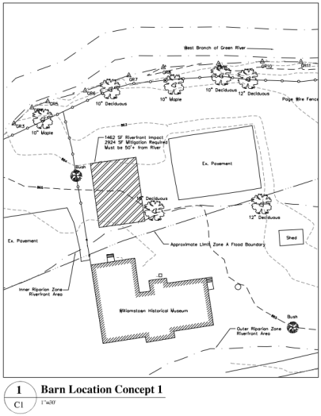
Attachment 5, cont.
Guntlow & Associates, Barn Location Design Concept 2
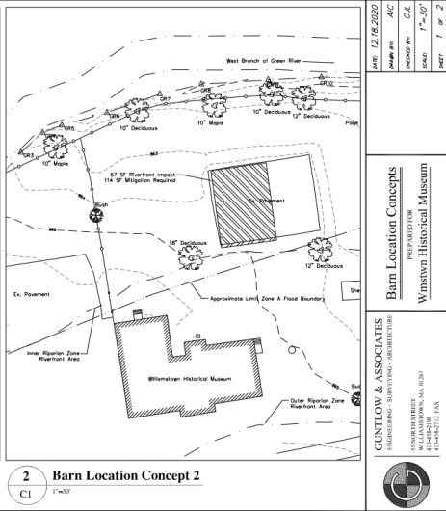
Attachment 5, cont.
Guntlow & Associates, Barn Location Design Concept 3
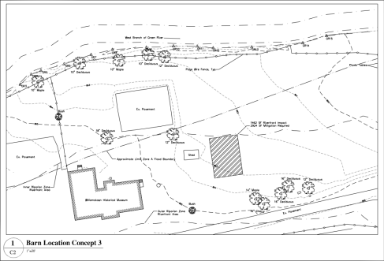
Attachment 6.
Babcock Brothers Restoration, Barn Project Estimate
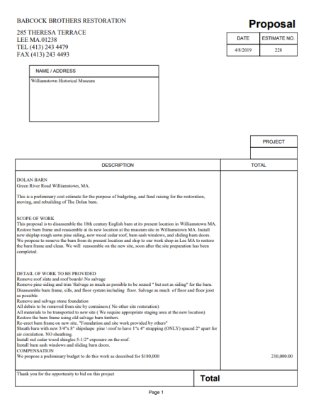
Attachment 6, cont.
Babcock Brothers Restoration, Barn Project Estimate, cont.
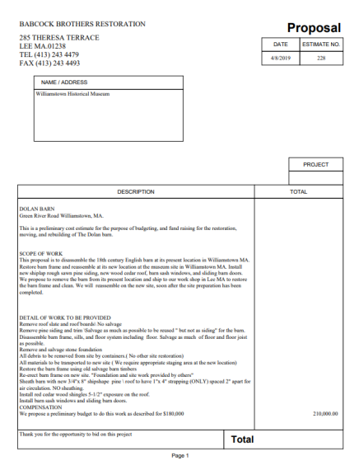
Attachment 7.
Grady & Jennings Concrete, Estimate for Foundation
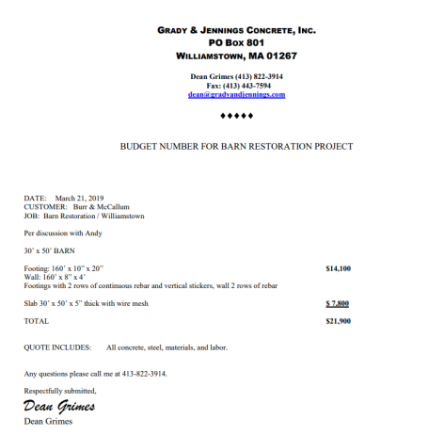
Attachment 8.
Project Team Member Resumes – David Babcock
Though David does not have a resume, he provided the following description of his company and work.
Babcock Brothers Restorations Inc. began in 1983 as Babcock Brothers Construction. A year later we incorporated and became Babcock Brothers Restoration Inc. The company is owned and operated by David W. Babcock who has been in the restoration industry for more than 30 years. David Babcock is the eldest son of the famous barn preservationist Richard W Babcock. The elder Babcock is world
renowned as one of the most significant people of our time for preserving not only these incredible structures but their history, and valuable contribution to the development of our great country.
It was while working on these projects with his father, building restoration became the inspiration for David to dedicate himself to creating a company that would be engaged in restoring and preserving buildings for future generations.
It is our main focus to be involved in projects that have a historical aspect to them whether it’s saving a barn from being lost to the ravages of time, or restoring an early colonial home to its original glory, to perhaps the conversion of a early timber framed structure to a unique and interesting new home.
We realize the importance of incorporating today’s appointments and conveniences in our projects, and finding a way to do this without sacrificing the original beauty and elegance of the original design. We accomplish this by working closely with our clients and finding solutions and providing them with options to achieve the results they want. Our ability to accomplish this has become one of our most important trade marks.
Attachment 8, cont.
Project Team Member Resumes - Andrus Burr
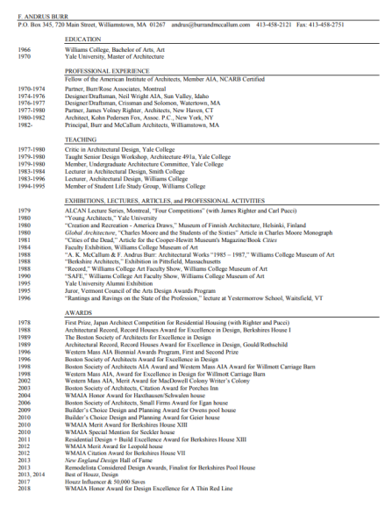
Attachment 8, cont.
Project Team Member Resumes - Andrus Burr, cont.
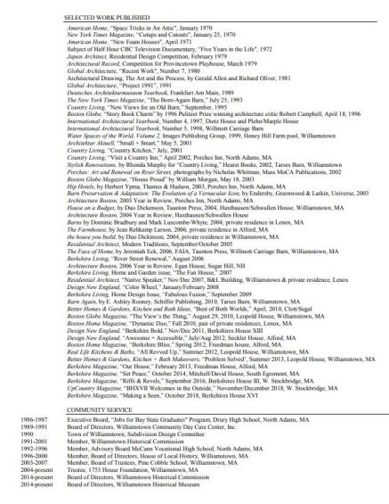
Attachment 8, cont.
Project Team Member Resumes – Linda Conway
From the WHM Board Member Bios:
Linda Glick Conway, a graduate of Wells College, worked for 25 years in Boston in book publishing, ultimately as managing editor in the Trade Division of Houghton Mifflin Company (now Houghton Harcourt). Since moving to Williamstown in 1986 with her husband, James Conway, she has written several cookbooks and done free-lance editing for local publishers. She has served on the boards of the Longy School of Music in Cambridge, the Berkshire Unit of Recording for the Blind and Dyslexic (now Learning Ally), 18 Degrees (formerly Berkshire Children and Families), the Milne Public Library, the Williamstown Community Chest, and the Salvation Army of North Adams. She has also been a member of the Williamstown Historical Commission and the Community Preservation Committee. Linda and her husband owned the Judah Williams house on Main Street, the first brick house built in Williamstown, c.1770.
Attachment 8, cont.
Project Team Member Resumes – Sarah Currie
Professional Experience:
2010 – present Williamstown Historical Museum, Williamstown, MA 01267 Executive Director (2013 to present)
2008 - 2009 How Green is My Town, Long Island, NY
Green Links Research Consultant
2007 – 2008 Maggie Wood Design, Long Island, NY
Green Design Research Consultant
2007 Cindy Ray Interiors, Palm Beach, FL
Interior Design Assistant
2004 - 2006 UMass Housing Services Design Office, Amherst, Massachusetts Interior Design Intern/Project Manager
2002 – 2004 Williamstown House of Local History, Williamstown, Massachusetts Curatorial Assistant
Education:
2002-2006 UMass, Amherst
Amherst, Massachusetts
Master of Science in Interior Design
2001–2002 Berkshire Community College
Pittsfield, Massachusetts
Completed a wide range of art and art history courses in preparation for graduate study.
1993-1997 Franklin and Marshall College
Lancaster, Pennsylvania
Bachelor of Arts degree in Sociology with a concentration in English
Attachment 9.
List and Bios of Williamstown Historical Museum Board Members
Joe Bergeron
Throughout his career, Joe has operated in a variety of management roles, but always stayed true to his roots as a software engineer and enabler of software development teams. He has worked as a founder, consultant and advisor. Joe’s software experience spans developing financial transaction processing systems, retail systems, web-based consumer applications, mobile and tablet applications, interactive television platforms and application and business process infrastructure. Beyond software engineering, Joe has led fundraising, team development, strategic partnership, technical sales and brand development efforts.
Dante Birch
Dante Birch grew up in Philadelphia, PA and Hanover, NH. He is a graduate of the oldest art school in the nation, The Pennsylvania Academy of Fine Arts. He attained his BFA from the University of Pennsylvania and his Masters degree in the historic preservation of architecture from UMass Amherst. He has worked in the arts, in galleries and museums for the majority of his career, a decade of which was dedicated to MASS MoCA where he was the Director of Exhibition Planning until he left to join Kapiloff’s Glass, Inc. Currently he works in the Commercial Construction Sector where he is a senior project manager for Kapiloff’s Glass, focusing publicly funded infrastructure projects. He lives in Williamstown, MA with his lovely wife Krista and his tenacious daughter Flora. He is a sitting member of the Williamstown Planning Board. With an intense interest for history and cultural institutions, he believes access to local history is an important underpinning of community.
Paul Boyer
Paul was a Williamstown resident 1955-2004. Born in North Adams, he now again lives in North Adams in the 1880 house built by Colonel Marion, who fought in the Civil War. In September 2019 Paul and his brothers sold the family homestead on the corner of Maple and Elm Streets in Williamstown, a property purchased by his grandfather in 1920, three generations and 99 years later.
Paul retired from Williams College in 2018 as the Director of Financial Aid. He was employed at Williams for 39 years, serving 36 in the Office of Financial Aid. During these years he assisted in or was responsible for awarding nearly one billion dollars in need-based financial assistance to students representing over half the living alumni body - from across the globe - better than 90% of the funds coming from Williams itself. He is the recipient of the Frederick Copeland Award for service to Williams alumni. Paul’s professional work included: National Association of Financial Aid Administrators; annual conference presenter, Eastern Association of Financial Aid Administrators; Massachusetts State Representative 1998; Massachusetts Association of Financial Aid Administrators: President 1996-1999, Executive Council 1994-1996, annual Conference Co-chair 1990-1996; College Goal Sunday and Berkshire County high school financial aid night presenter and contributor. Williams College Faculty Club: President 1997-1999, Board of Governors 1990-1999, Holiday Craft Show Co-chair and vendor 1994-1999.
Volunteer opportunities: Williamstown Holiday Walk Committee 1990's, St Raphael Church Bazaar Committee 1990's.
Attachment 9, cont.
List and Bios of Williamstown Historical Museum Board Members
Paul Boyer, cont.
Education: BA Biology Williams College 1977, Mt Greylock Regional High School 1973.
Paul’s hobbies and interests include interior design, gardening, antiques, furniture restoration and crafting. He is a member of the Bichon Frise Club of Southern New England.
Robert Burns
Robert Burns’ family dates to the early days of Williamstown and his interest in local history extends to the classroom where he has worked for years as a teacher and director of the Starlight Stage Company. His current interests and writing are focused on a WWI veteran.
Andrus (Andy) Burr
Andrus Burr is a founding partner in Burr and McCallum Architects of Williamstown. Andy is a Fellow [for design] of the AIA and he received his B.A. from Williams College and his M. Arch from Yale. He has taught architectural design at Williams College, Smith College, and Yale University. In thirty years of practice he and his partner Ann McCallum have designed numerous buildings in Berkshire County and beyond. In addition, Andy has served on the Williamstown Historical Commission, and has been involved in issues of historic preservation for the past twenty years.
Donna Chenail
Donna Chenail was born in the Bronx, NY. She has a degree from City Tech in Brooklyn. She worked in Manhattan from 1964 through 1968 and 1972-1976 in the legal assisting world.
She moved up to Williamstown, Massachusetts, in 1976 where she obtained the position of coordinator of the Faculty Secretarial Office. She retired in 2010. During her life spent in Williamstown she and her husband, Richard, managed Chenail’s Farm Fresh Products which she now co-owns with her stepdaughter Pamela Shea. She has a combination family of 8 children and 19 grandchildren. Her early interest in history began with her great aunt who told her she could join the DAR (Daughters of the American Revolution) and the ensuing research pertaining to joining the organization.
Linda Conway
Linda Glick Conway, a graduate of Wells College, worked for 25 years in Boston in book publishing, ultimately as managing editor in the Trade Division of Houghton Mifflin Company (now Houghton Harcourt). Since moving to Williamstown in 1986 with her husband, James Conway, she has written several cookbooks and done free-lance editing for local publishers. She has served on the boards of the Longy School of Music in Cambridge, the Berkshire Unit of Recording for the Blind and Dyslexic (now Learning Ally), 18 Degrees (formerly Berkshire Children and Families), the Milne Public Library, the Williamstown Community Chest, and the Salvation Army of North Adams. She has also been a member of the Williamstown Historical Commission and the Community Preservation Committee. Linda and her husband owned the Judah Williams house on Main Street, the first brick house built in Williamstown, c.1770.
Attachment 9, cont.
List and Bios of Williamstown Historical Museum Board Members
Carole Dolan
A nearly lifelong resident of Williamstown, and a descendant of the Green and Jenks family, Carole adds her skills to the WHM Communications Committee as its chair. She served as a conscientious and highly regarded administrator at the North Adams Regional Hospital and now uses her skills as the Communications Committee chair at the Williamstown Historical Museum.
Paul Dube
Paul Dube served on the board of directors of the Greylock Federal Credit Union for several decades and is interested in Williamstown’s history as an experienced business professional. He has served on numerous boards and committees throughout the region since his retirement.
Pat Greenberg
Pat Greenberg is a graduate of Bates College with a degree in American History. She retired to Williamstown in 1997 from Westchester County NY and has served on the Board of Directors of the South Williamstown Community Association for eight years, the last three as President. Pat has served on the Williamstown Historical Museum Board of Directors for six years on various committees and as docent.
Stephanie Johnson
Stephanie loves to learn and has shared her interest in art, history, and culture with young people for the past 12 years as a docent at the Clark Art Institute. Stephanie and her husband, Charles Bonenti, have lived in Williamstown for 44 years. Her professional work has always involved communicating ideas. She earned by BA in English Literature from Williams College in 1989 when she returned to college. Prior to moving to Williamstown in 1971, she was for seven years an editorial assistant at Conde Nast Publications in New York City. The first job she had in Williamstown in 1972 was as a journalist/photographer for seven years for The North Adams Transcript. She was awarded First Place, 1980, New England Press Association, for Living Page feature and Special Section layout. As a freelance writer she has written for: The Berkshire Eagle, been a stringer for New York Times, written for regional publications, local and national arts organizations (Edith Wharton Restoration, Williamstown Theatre Festival), and was employed by a professional fund raiser to write client development materials for national arts organizations. She has written, created, or managed alumni publications for Bennington College, Williams College and Massachusetts College of Liberal Arts.
As an author she wrote: the first guidebook to the Berkshires, The Best of The Berkshires, (1979), Globe–Pequot Press, and ghostwrote a primer on mutual fund investing. She has served on numerous boards including The Williamstown Community Chest, ABC, The Berkshire Williams Alumni Association (President) Berkshire Humane Society, Williamstown Garden Club (President) and the Boys & Girls Service League of New York City.
Attachment 9, cont.
List and Bios of Williamstown Historical Museum Board Members
Patricia Leach
Patricia Leach retired to her longtime Williamstown home in 2011 after serving five years as Director of Development for the Delaware Center for the Contemporary Arts. She recently served as President of the WHM. She first settled here in 1975 and has considered Williamstown home ever since. She earned a Ph.D. and M.F.A. in the Department of Art and Archaeology, Princeton University where her studies focused on 16th c. Venetian drawings and 15th c. Florentine art and politics. She graduated Magna cum Laude and Phi Beta Kappa with departmental honors in art history from Franklin and Marshall College. Earlier on, after three years of study, she earned a diploma in advertising and design from the York Academy of Art. Ms. Leach is a first-generation college graduate. Mentored by Whitney Stoddard and S. Lane Faison, she taught for 23 years in the Department of Art at Williams, created the Education Program at WCMA and recruited the first undergraduate docent group, the Museum Associates. During this time, she also served as editor for the Répertoire international de la littérature de l’art. Her studies of the drawings of Jacopo Bassano and the sculpture of Donatello’s David have appeared in The Princeton Art Museum Journal and Source. Along the way, she raised two wonderful children. She is now a very proud grandmother. At present, her research centers on 14th c. Italian art and images of women in the 19th and early 20th c.
Cynthia Payne
Cynthia D. Payne, is a twenty-eight years a Williamstown resident, married and the mother of four children. She has volunteered with Little Red Schoolhouse, Williamstown Elementary School, Williamstown tourist information booth, Milne library book sale, Berkshire Humane Society. She served as the ABC head tutor, a member of the Williamstown 250th Anniversary Committee, and worked on the Williamstown: The First 250 Years book, sang with "Celebrate Wassail." She is a First Congregational church member, former head deacon, and currently serves on the Outreach Committee and as co-chair of the tag sale, the church's biggest fundraiser. A genealogist, she belongs to the New England Historic Genealogical Society. She first joined the board of the House of Local History in 1998 and was editor of the newsletter until 2012. She formerly lived in the Sumner Southworth house on Main Street, and in 1998 bought the Botsford house, former home of the town library and the House of Local History. She spent 18 months restoring it to a private home which has been on the WHM house tour twice and on an Elderhostel tour of historic homes.
Patrick Quinn
Patrick J. Quinn is a fourth generation Williamstown resident who returned to Williamstown with his partner, Grant Sun, after 40 years in human service management and as a psychiatric social worker in the San Francisco Mobile Crisis Treatment Team. Patrick is a graduate of Catholic University, Washington, D.C., with a Master’s in education from Antioch University New England and a Master’s degree in social work from the University of Connecticut. Along with restoring a 1780’s house in Williamstown he has served with a number of local organizations, including Higher Ground and the Williamstown Affordable Housing Trust. He also served as the president of the Williams College Faculty Club and is a member of the board of the Williamstown Historical Museum where he is also a greeter.
Attachment 9, cont.
List and Bios of Williamstown Historical Museum Board Members
Susan Shaw Schneski
Susan attended Middlebury College ‘63 and earned graduate credits at Middlebury and Cornell University. She is retired from the Williams College Department of Music and served as Assistant to the Chair. Her interest in history grew from researching her ancestors and from living in South Williamstown near Five Corners National Historic District, including South Center School. She participated in cemetery preservation efforts through South Williamstown Community Association. In addition to her board membership on the WHM, she is a member of the Hoosick Township Historical Society. She is a past member of the Williamstown Historical Commission.
Mary Strout
Mary has lived and worked in Williamstown for 37 years. Currently, she works part-time for Anna Singleton, Executive Director, of the Williamstown Community Chest. Previously, she was employed at MountainOne Bank, holding various positions throughout the company, for 23 years. She has supported our community, volunteering at a number of events and serving on boards.
A brief history of her activities:
➢ Volunteer, Chapter Two Books (2019 – present)
➢ Board member Elder Services of Berkshire County, Inc. (2016 -2019)
➢ Board member, Secretary, Williamstown Community Chest (2014 – 2017) ➢ Board member Friends of the Library (2014 - 2015)
➢ Board member Williamstown Chamber of Commerce (2006 – 2012)
➢ Co-chair, Williamstown Chamber of Commerce (2008 – 2010)
David Westall
David is currently nearing full retirement at Hake-Westall Architecture (formerly Westall Architecture). Prior to establishing his own firm, Mr. Westall worked for Ekstrom/Nijhuis, Inc. in North Adams, MA as an Architectural Draftsman / Designer where he was a draftsman and designer of residential, commercial, and public projects.
Mr. Westall was later employed by Williams College, Williamstown, MA as the Assistant Director for Architectural Services serving as designer, draftsman, specifier, and construction supervisor of new construction, additions, alterations, and renovations of College projects.
Emeritus Board Members:
John Hyde
Samuel Westcott

