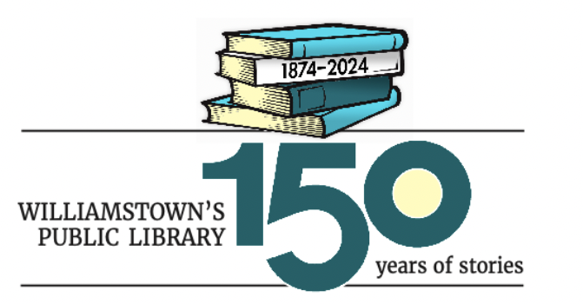

Patrons and friends of Williamstown’s public library will come together in 2024 to celebrate the library’s 150th anniversary with many events centering on books, libraries, and reading. All events are free, and up-to-date information can always be found on the library’s website: www.milnelibrary.org.

Library displays of 1874 publications - In honor of the 150th anniversary of Williamstown’s public library, during the months of March and April the Clark Art Institute Library will mount a display of art books published in 1874. This display will be accessible when the library is open to the public: Monday through Friday, 9:00 a.m. - 5:00 p.m. The Williams College Libraries Special Collections Department will have two displays of books published in 1874, one during March and a second rotating in on April 1. The displays will be in the Instruction Gallery on the 4th floor of Sawyer Library, open to the public Monday through Friday, 10:00 a.m.-4:00 pm.

Williamstown Public Library’s 150th Anniversary Film Series will focus on the transformative power of books and reading and is generously funded by the Clark Art Institute. Location of free screenings: the Clark Auditorium, 225 South Street, Williamstown.

The NeverEnding Story ~ Thursday, 3/7 at 6:00 p.m.
The Princess Bride ~ Thursday, 3/14 at 6:00 p.m.
Fahrenheit 451 ~ Thursday, 3/21 at 6:00 p.m.
84 Charing Cross Road ~ Thursday, 3/28 at 6:00 pm
Adaptation ~Thursday, 4/4 at 6:00 pm

150th Anniversary Open House at the Milne Public Library, 1095 Main Street in Williamstown ~ Saturday, March 9, 11:00 a.m. - 2:00 p.m.
Drop by and visit with library staff, volunteers, trustees, and Friends as we begin our next 150 years.
- Trio Café Budapest entertains with toe-tapping music.
- Davis Bates, award winning singer and storyteller, will present two programs of participatory folk songs and stories for all ages at 11:15 a.m. and again at 1:15 p.m.
- Robin Brickman, nationally known illustrator and school workshop leader, will present two one-hour bookmark-making workshops for children (ages 5 and up) at 11:15 a.m. and again at 12:45 p.m.
- Free prize drawings
- Anniversary cupcakes and lemonade from M & J’s Taste of Home Events and Catering.

The Williamstown Public Library’s 150th anniversary open house is made possible through generous funding by Trustees and Friends of the Milne Public Library.

“The History of the Williamstown Public Library” ~ Saturday, April 13, 2:00 p.m. at the Milne Public Library. Dustin Griffin, local author and lecturer, will discuss the history of Williamstown and the role of the public library within the town. Free event.

Public Book Group Conversation: The public is invited to a free, open book group conversation about a mystical library as described in “The Library of Babel” by Jorge Luis Borges ~ Tuesday, April 16 - 10:00 a.m. at the Milne Public Library.

Gallery tour: “1874, A Significant Year”~ Saturday, April 27, 2:00 p.m. at the Clark Art Institute, 225 South Street, Williamstown, MA. Jock Brooks, retired associate director of the Clark, will lead a gallery tour exploring works of art made in 1874, the year Williamstown’s Public Library was founded. Free with gallery admission. Meet in the museum pavilion.

The Book Club Play by Karen Zacarias ~ Two performances: Saturday, May 4, 1:30 p.m. at the Milne Public Library, 1095 Main Street, Williamstown, and Sunday, May 5, 2:00 p.m. at Sweetwood, 1611 Cold Spring Road, Williamstown, MA. Local actors will undertake a staged reading of this comedic play about the meltdown of a book group.

Thomas E. Johnson, Jr., author of Common Place: The Public Library, Civil Society, and Early American Values will speak on Saturday, May 11, at 2:00 p.m. on the topic of Massachusetts Libraries, Past and Future. Location: Milne Public Library.

Award-winning author Elizabeth Winthrop Alsop will speak about her most recent book, Daughter of Spies: Wartime Secrets, Family Lies ~ Wednesday, June 26, 6:00 p.m. at the Milne Public Library.

Gallery tour: “1874, A Significant Year”~ Saturday, September 28, 1:00 p.m. at the Clark Art Institute, 225 South Street, Williamstown, MA. Jock Brooks, retired associate director of the Clark, will lead a gallery tour exploring works of art made in 1874, the year Williamstown’s Public Library was founded. Free with gallery admission. Meet in the museum pavilion.

Julia McKenzie Munemo, director of the Writing Center at Williams College, will speak about her most recent book The Book Keeper: A Memoir of Race, Love, and Legacy – date in early October tbd – at the Milne. Check www.milnelibrary.org for up-to-date information.

Local authors Jim and Karen Shepard are in the English Department at Williams. Karen is the author of several novels, including The Celestials which is set in North Adams. Jim is an award-winning novelist, short story writer, and essayist. They will present a program in late October, date tbd - at the Milne. Check www.milnelibrary.org for up-to-date information.

Local artists will honor the library with an art show scheduled to run for the month of December. Reception on Wednesday, December 4 at 4:00 p.m. in the main lobby of the Milne Library.

The events and programs of the Williamstown Library’s 150th anniversary are made possible through generous funding by lead sponsor MountainOne, your local Berkshires bank.

David and Joyce Milne Public Library
1095 Main Street, Williamstown, MA 01267
www.milnelibrary.org
413-458-5369

